CS 255 System Design Document Template

This template lays out all the different sections that you need to complete for Project Two. Each section has guidance to prompt your thinking. You will need to continually reference the interview transcript as you work to make sure that you are addressing your client’s needs. There is no required length for the final document. Instead the goal is to complete each section based on what your client’s needs are. Remove this note when you are finished, and replace all bracketed text with the relevant information.

UML Diagrams

UML Use Case Diagram
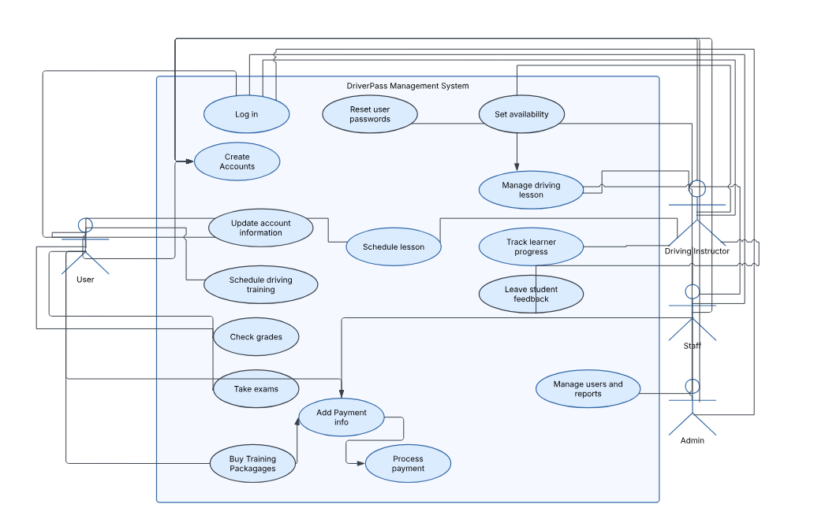

UML Activity Diagrams
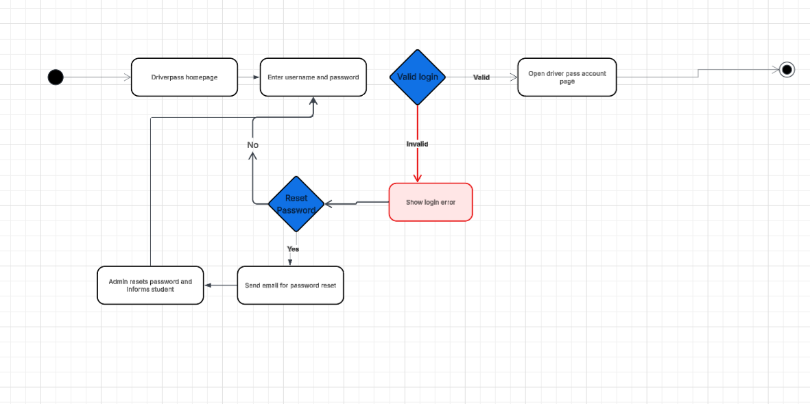

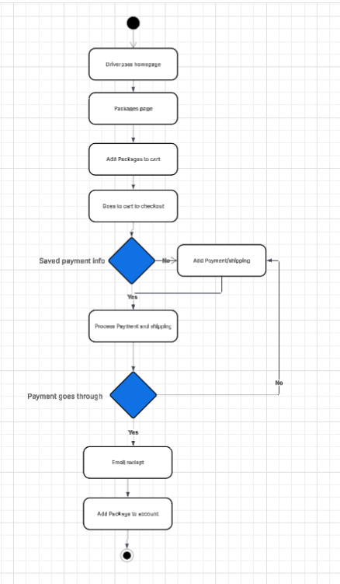

UML Sequence Diagram

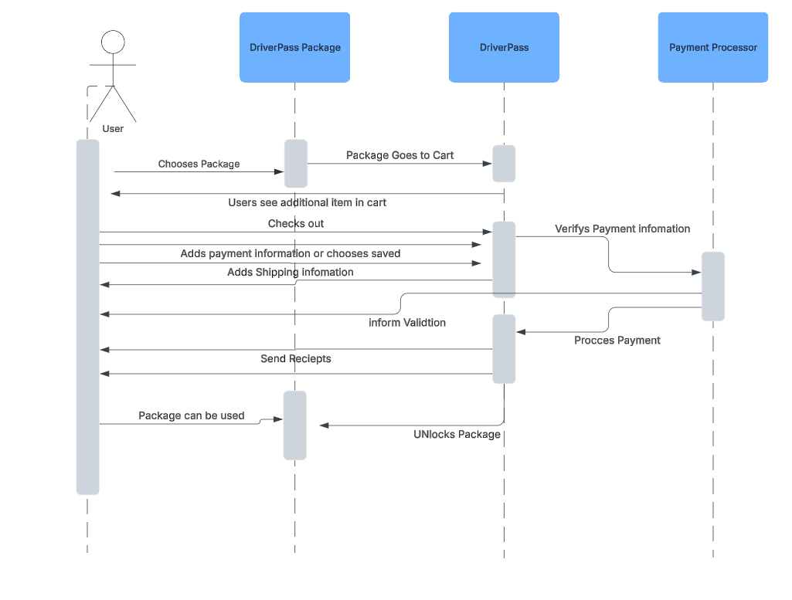

UML Class Diagram
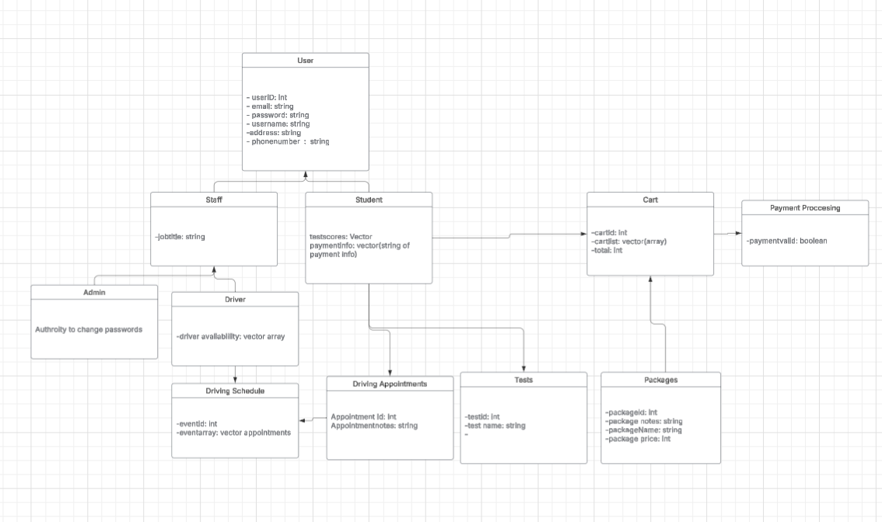

Technical Requirements
Hardware Requirements:
- Dedicated Servers
- Internet access
- Staff Computers
- Raid Storage for servers
- firewall
Software Requirements
- A SQL Server for a structured database
- Windows Server
- Javascript, HTML, and CSS to build a webpage

